Financial Module
Main Database
Cost Center
Supplier
Customer
Banks

WHT Rates
Accounts
GL Accounts

FSF Accounts

Banks

Opening Balance

FN-Statement Policy

Main Transactions
Receipt Vouchers
Payment Vouchers
Journal Vouchers
Purchase Vouchers
Sale Vouchers
Supplier’s Settlement
Customer’s Settlement

Table of Contents

Requirements Analysis
Systems Characteristics
Integration to Other Modules
User Pre-Requisites
Getting Started
Setups
- Financial Account File ......................................................................................................
- General Account File ……………………………………………………………………………………………………
- Opening Balance File …………………………………………………………………………………………………..
- FN-Statement Policy File ……………………………………………………………………………………………..
- Cost Center File ………………………………………………………………… ………………………………………
- Bank File …………………………………………………………………………………………………………………….
- Supplier File ……………………………………………………………………………………………………………….
- Customer File ……………………………………………………………………………………………………………..
- WHT Rates File …………………………………………………………………………………………………………..
- Budget Forecast File …………………………………………………………………………………………………….
- Document Serial File …………………………………………………………………………………………………….
Transactions
- Cash Receipt Voucher: Recording Receipts in Cash …………………………………………………………
- Cash Payment Voucher: Paying in Cash …………………………………………………………………………
- Bank Receipt Voucher: Recording Receipts through Checks ……………………………………………..
- Bank Payment Voucher: Paying through Checks ……………………………………………………………..
- Journal Voucher: Recording of ……………………………………………………………………………………….
- Purchase Voucher: Recording of Purchase ………………………………………………………………………
- Sale Voucher: Recording of Sale …………………………………………………………………………………….
- Supplier’s Settlement: …………………………………………………………………………………………………..
- Customer’s Settlement: ……………………. ………………………………………………………………………….
Reports
- Financial Statement Heads ……………………………………………………………………………………………
- Chart of Accounts ………………………………………………………………………………………………………..
- Opening Balance …………………………………………………………………………………………………………
- FN-Statement Policy …………………………………………………………………………………………………….
- Cost Centre Listing ………………………………………………………………………………………………………
- Bank Listing ………………………………………………………………………………………………………………..
- Supplier Listing ……………………………………………………………………………………………………………
- Customer Listing ………………………………………………………………………………………………………….
- WHT Rates Listing ……………………………………………………………………………………………………….
- Budget Forecast …………………………………………………………………………………………………………..
- Document Serial Listing ………………………………………………………………………………………………..
- Transaction Logs ………………………………………………………………………………………………………….
- Voucher Listing …………………………………………………………………………………………………………….
- Financial Books ……………………………………………………………………………………………………………
- Trial Balance ……………………………………………………………………………………………………………….
- Ledger ………………………………………………………………………………………………………………………..
- I-Tax Challan ……………………………………………………………………………………………………………….
- I-Tax Certificate …………………………………………………………………………………………………………..
- I-Tax Statement …………………………………………………………………………………………………………..
- Aging …………………………………………………………………………………………………………………………..
Utility Tools
- Auditing Process ………………………………………………………………………………………………………….
- Posting Process ……………………………………………………………………………………………………………
- Un-Posting Process……………………………………………………………………………………………………….
- JV Generation ………………………………………………………………………………………………………………
- SV Generation …………………………………………………………………………………………. …………………
- Tax Payment Process …………………………………………………………………………………………………..
- Tax Challan Process ……………………………………………………………………………………………………
- Receivables and Payables Process ……………………………………………………………………………….
- Cash Physical ………………………………………………………………………………. …………………………..
- Manual Income Tax Challan …………………………………………………………………………………………
- Supplier Exemption ………………………………………………………………………………. …………………..
Requirements Analysis
Systems Characteristics
Integration with Other Modules

FCL Financial Module is linked with the following FCL modules:

- Inventory -INV
- LC Management - LCM

GL INV

LCM
Dependency Diagram

Relationship with Inventory Module

- Cost Centers, Customers and Suppliers are updated in Financial and Inventory Modules equally
- Inventory Module fetches all GL Account heads to link them with Item Master file and make transactions
- Purchase Vouchers in Inventory module can’t be made if the transaction date is locked/posted by the FCL Financial Module. Also, document serial numbers for Inventory PVs are maintained in FCL financial (GL) Module

Relationship with LC Management Module

- An LC Setup entry updates FCL Financial Module with a brand new account head with the LC number specified; which is then used to pay off the LC voucher made through LC Transaction

User Pre-Requisites
Getting Started

Setup
_______________________________________________________________________________

Setup files are data entry screens for the following main database entities of the Financial Module:

- Financial Accounts
- General Accounts
- Opening Balance
- FN-Statement Policy
- Cost Center
- Bank
- Supplier
- Customer
- WHT Rates
- Budget Forecast
- Document Serial Nos

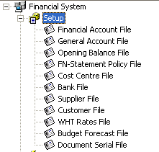 | 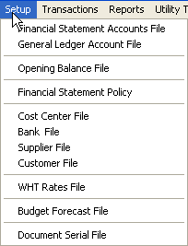

In the subsequent pages, each Setup entry is described briefly with the help of screen-shots.

Financial Accounts File
_______________________________________________________________________________

Description
A simple Code-Name data entry form for keeping record of different levels of financial statement accounts which are associated with GL Accounts with the help of Financial Statement Policy; the corresponding code-length is 2, 4, and 7, respectively.

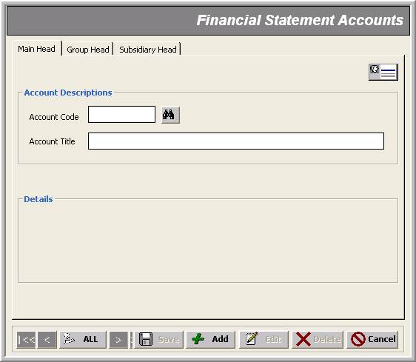
* Account Name (@³⁰)

* Main Level Code (@@)

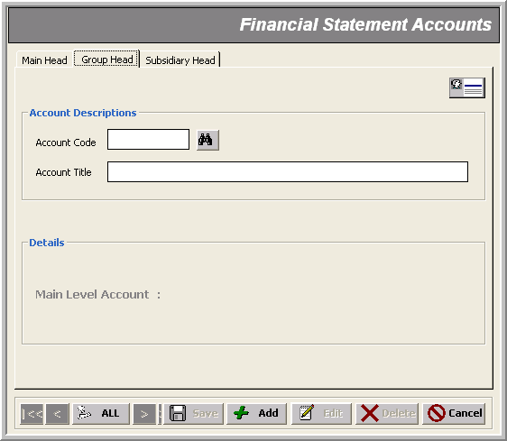
* Account Name (@³⁰)

* Group Level Code (@@@@)

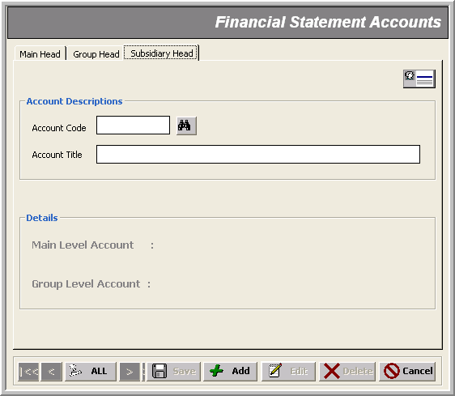
* Account Name (@³⁰)

* Subsidiary Level Code (@⁷)
General Accounts File
_______________________________________________________________________________

Description
The heart of GL module where we define four levels of accounts; namely: Group, General, Subsidiary and Sub-subsidiary; the corresponding code-length is 2, 4, 8 and 11, respectively.

Note that:
- For Financial Statement Reports, we specify which Debit/Credit Account Heads are going to be affected for a particular Financial Statement Account related change

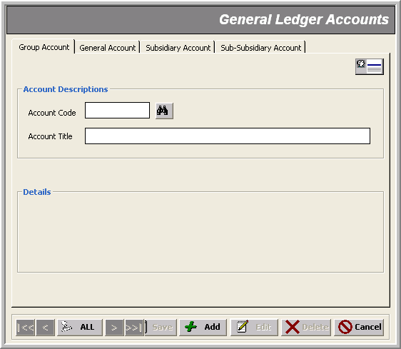
* Account Name (@³⁰)

* Group Level Code (@@)

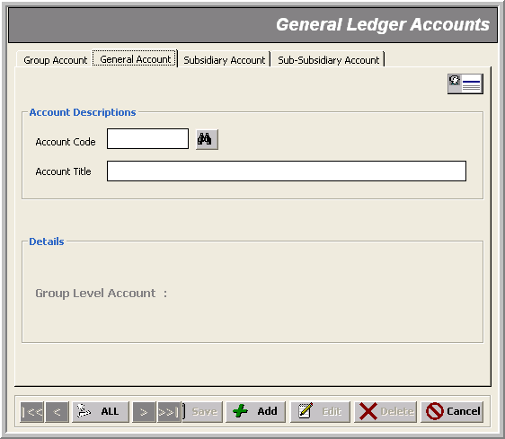
* Account Name (@³⁰)

* General Level Code (@@@@)
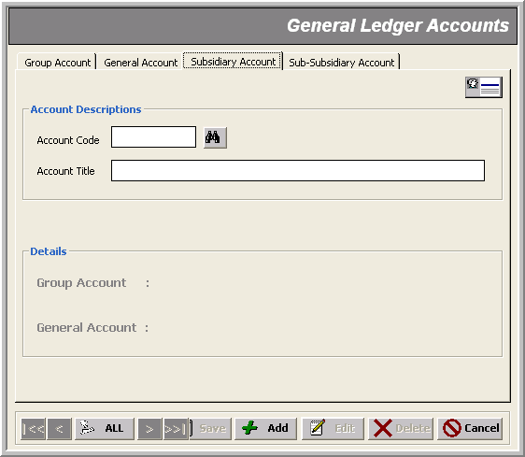
* Account Name (@³⁰)

* Subsidiary Level Code (@⁸)
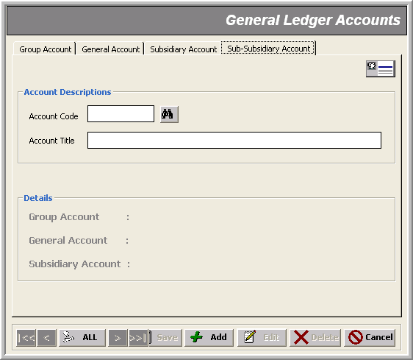
* Account Name (@³⁰)

* Sub Subsidiary Level Code (@¹¹)
Opening Balance File
_______________________________________________________________________________

Description
This form is used for entering opening balances of different account heads as either Debit or Credit.

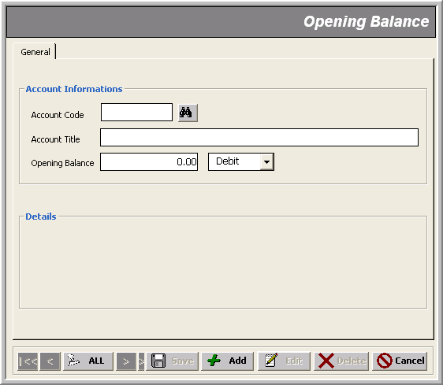
Amount in Dr or Cr

* Account Code of Any Level

FN Statement Policy File
_______________________________________________________________________________

Description
This form helps you relate a Financial Statement Account with the GL Accounts which are going to be affected for a Debit/Credit change in that FIN Account. Hence, the Financial Statements are maintained accordingly.

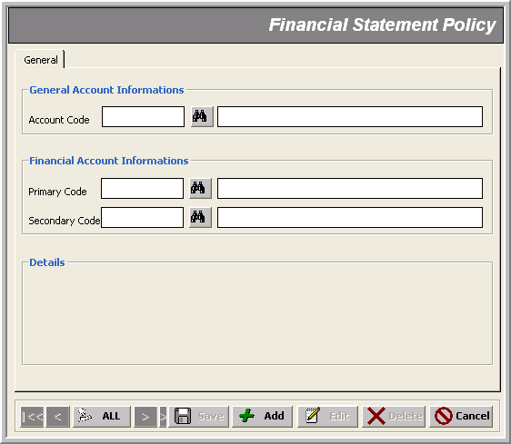
Financial Accounts Head
* GL Account of any Level

Cost Center File
_______________________________________________________________________________

Description
A simple Code-Name data entry form for keeping record of different sections of ‘Production’ or ‘Non-Production’ departments. Ttransactions made with reference to a cost center helps the financial module track financial activities cost center wise.

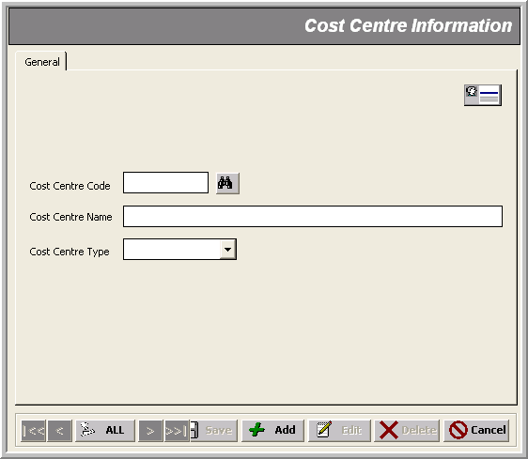
* Cost Center Name (@³⁰)

* Cost Center Code (@@)
Cost Center Type

Bank File
_______________________________________________________________________________

Description
Here we specify the banks’ information that FCL deal with for its financial activities. The GL account defined by GL Code is used to record the bank related transactions.

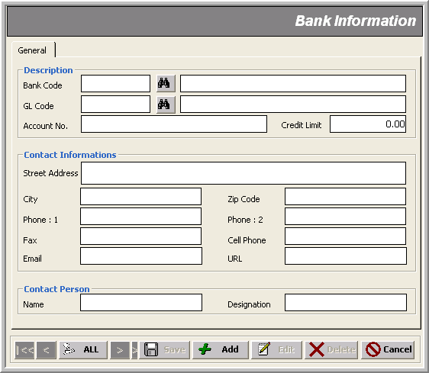
Bank Account No
* Bank Code (@@)
* Last Level GL Account
Credit Limit
Other Bank Info
Supplier File
_______________________________________________________________________________

Description
This form keeps information about suppliers such as name, contacts, income/sales tax Nos., credit days and bank information.

Note that:
- Changes made in Suppliers’ data get updated in all FCL Modules (Inventory, Production, etc)

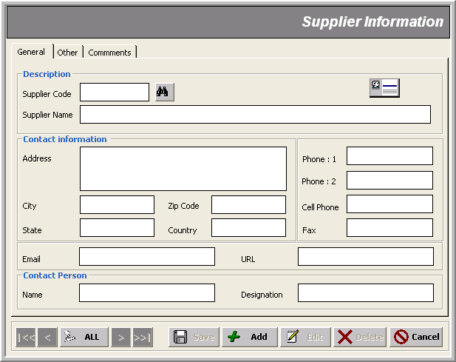
* Supplier Name (@⁴⁰)
Supplier Contacts
* Supplier Code (@⁸)
Supplier Contact Person

Note that:
- In Other tab, we can save other financial information about the supplier such as income tax, sales tax, credit terms and bank information
- Supplier’s Credit Days Limit specified here is used in aging of invoices

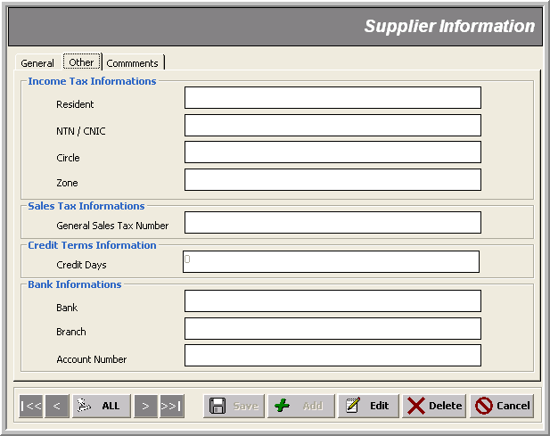
Supplier Credit Days Limit

Note that:
- In Comments tab, we can save away our remarks about the supplier date wise; this remains as is in all inventory modules

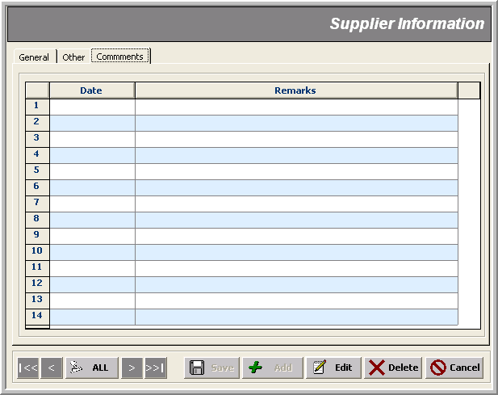

Customer File
_______________________________________________________________________________

Description
This form keeps information about customers such as name, contacts, income/sales tax Nos., credit days and bank information.

Note that:
- Changes made in Customers’ data get updated in all FCL Modules (Inventory, Production, etc)

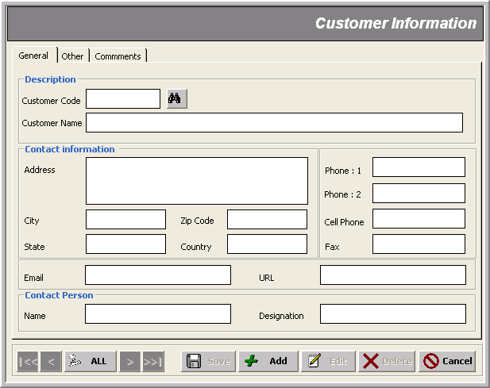
* Customer Code
* Customer Name
Customer Contacts
Customer Contact Person
Note that:
- In Other tab, we can save other financial information about the customer such as income tax, sales tax, credit terms and bank information
- Customer’s Credit Days Limit specified here is used in aging of invoices

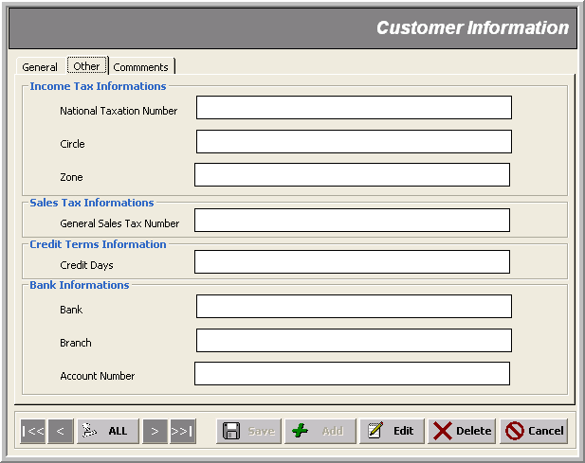
Note that:
- In Comments tab, we can save away our remarks about the customer date wise; this remains as is in all inventory modules

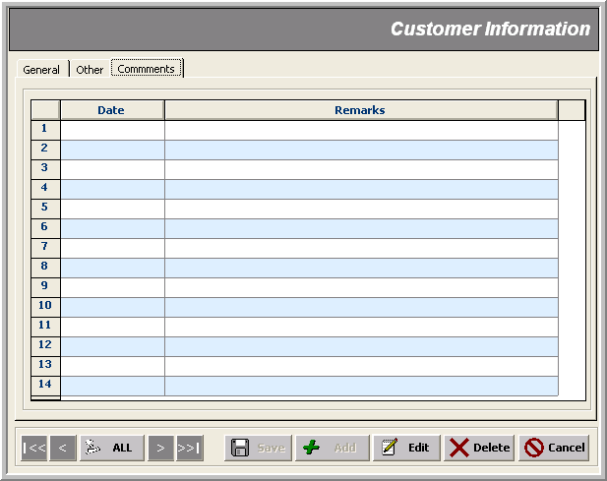
WHT Rates File
_______________________________________________________________________________

Description
In this form we specify the government’s prescribed rates of with-holding tax with reference of the related FCL’s Financial Expense Account Heads.

Note that:
- The GL expense Account labeled with ‘Tax Deduction’ belongs to customer tax deduction; while, ‘Advance I/Tax’ account is charged when we deal with a supplier

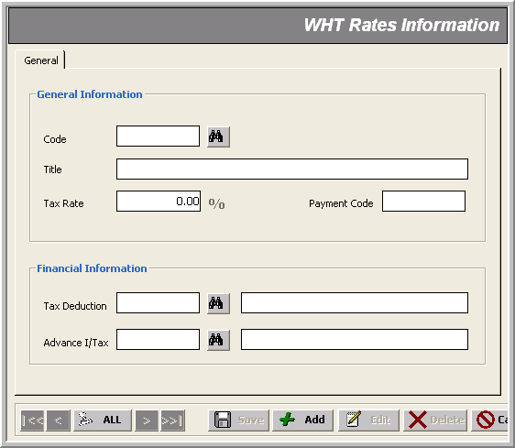
Tax Rate
* With-Holding Tax Code (@²)
GL Account Heads
Budget Forecast File
_______________________________________________________________________________

Description
This from helps us forecast monthly budget to be assigned for a particular GL account.

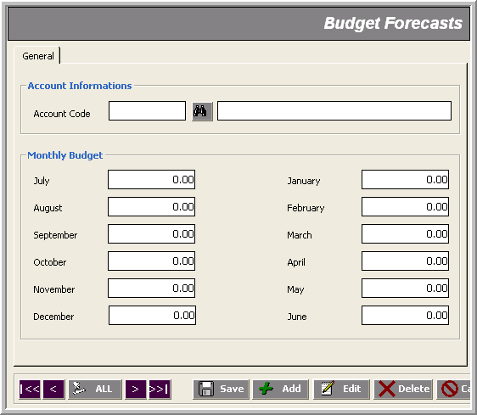
* Last Level GL Account

Monthly Budget
Document Serial File
_______________________________________________________________________________

Description
This form is used to specify serial numbers for all kinds of transactions; the general format is ‘yymmnnnn’ where:
‘yy’ => current year
‘mm’ => current month
‘nnnn’ => actual serial showing no of transactions of this type
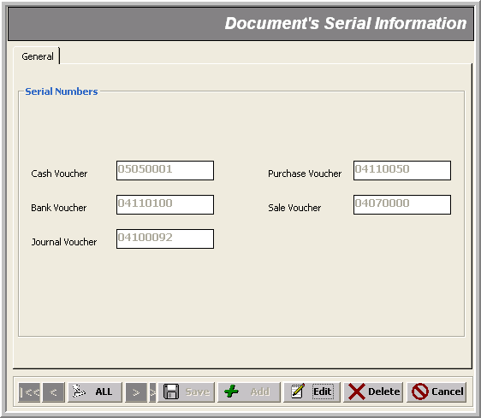
Transaction Serial No.’s
Transactions
_______________________________________________________________________________
There are nine transactions in the financial module that can be classified into the following categories:

- Recording Receipts in Cash - Cash Receipt Voucher
- Paying in Cash - Cash Payment Voucher
- Recording Receipts through Checks - Bank Receipt Voucher
- Paying through Checks - Bank Payment Voucher
- Doing Receipts or Payments on the fly - Journal Voucher
- Recording of Purchase - Purchase Voucher
- Recording of Sale - Sale Voucher
- Maintaining Suppliers’ Settlement in GL - Supplier’s Settlement
- Maintaining Customer’ Settlement in GL - Customer’s Settlement

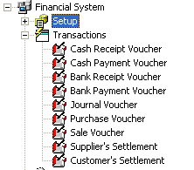 | 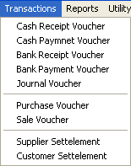

All transactions in the Financial Module are about creating vouchers!
In FCL Financial Module, receipts or payments (whether on cash or through bank) are recorded in three ways:
- through Normal Vouchers
- through Journal Voucher
- through Customer’s/Supplier’s Settlement Vouchers

Before we move on, let’s first take an overview of some ‘general’ and ‘FCL-specific’ meanings of these transactions:

Normal Vouchers
1- Generally speaking, we make them when we have to record ‘receipt of payment’ on an account (normally a customer as a credit account); creating Cash/Bank Receipt Vouchers for normal users is disallowed; only an administrator can do that.  2- In terms of FCL Financial module, we make Cash/Bank Receipt Vouchers on behalf of our ‘suppliers' as ‘adjustments’; which is allowed to all users with a confirmation prompt recommending the user to settle such a transaction through Supplier’s Settlement receipt voucher. | 1- Generally speaking, we make them when we have to record ‘payment’ for an account (normally a supplier as a debit account); creating Cash/Bank Payment Vouchers on behalf of ‘suppliers’ for normal users is disallowed; only an administrator can do that.  2- In terms of FCL Financial module, we make Cash/Bank Payment Vouchers on behalf of our ‘customers' as ‘adjustments’; which is allowed to all users with a confirmation prompt recommending the user to settle such a transaction through Customer’s Settlement payment voucher.
Journal Vouchers
Adjustments to a Cash/Bank Receipt or Cash/Bank Payment transactions is made through a Journal Voucher; FCL’s Financial module allows creating ‘Journal Vouchers’ on behalf of our ‘suppliers' or ‘customers’ as ‘adjustments’; but only an administrator can do that; normal users are disallowed selecting a ‘customer’ or ‘supplier’ account for this transaction

Settlement Vouchers
Sale Vouchers created in FCL Inventory (Finished Goods) module are settled in FCL Financial module through Customer’s Settlement receipt voucher; Customer's Settlement does two major jobs:  - updates FCL GL transactions with a brand new receipt  - maintains ‘taxation’ on those customer-related transactions applying government’s tax rules as specified by the administrator | Purchase Vouchers created in FCL Inventory modules are settled in FCL Financial module through Supplier's Settlement payment voucher; Supplier's Settlement does two major jobs:  - updates FCL GL transactions with a brand new payment  - maintains ‘taxation’ on those supplier-related transactions applying government’s tax rules as specified by the administrator

In the next sections, you will learn every transaction in details, with the following aspects keeping in view:

- Short Description with mandatory & optional fields info
- General Restrictions
- User Specific Control

Here are the general validations during the data entry of any transaction:

- fields marked with asterisk * in the snap-shots are mandatory
- transaction number gets generated automatically in ‘yymmnnnn’ format where:
yy => current year
mm=> current month
nnnn=> Auto generated serial no.
- transaction dates must lie within the same month as indicated by the transaction number; or else you get an error message:
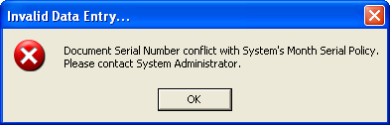
or
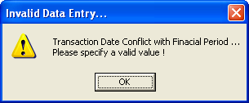
- A transaction gets LOCKED as soon it is created and can be editable only when Un-Posting Process is run by the authorized user (e.g. the administrator )
- Similarly, if the Posting Process has locked a date, transaction entry is disallowed thereon:
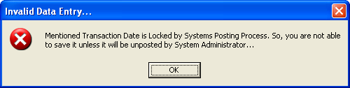
- No transaction is allowed if there is already some un-posted transactions:
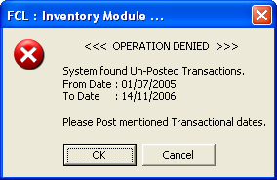
- Similarly, if Posting or Auditing process is currently in progress; the system denies any transaction entry with an alert like:
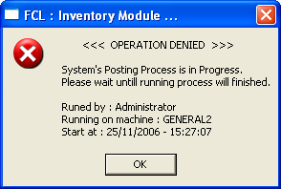

Cash/Bank Receipt Voucher _______________________________________________________________________________
Use case: Recording Receipts

Description
These forms are used to create Receipt Vouchers with the following mandatory data entry:

- Voucher No (Auto generated in ‘yymmnnnn’ format)
- Voucher Date
- Received From
- Check No (if receiving through check; mandatory in case of Bank Receipt Voucher)
- Drawn On (the customer’s bank with which the check is drawn; mandatory in case of Bank Receipt Voucher)
- On Account of
- More than one journal entry against a GL Account

Optional information includes:
- Cost Center

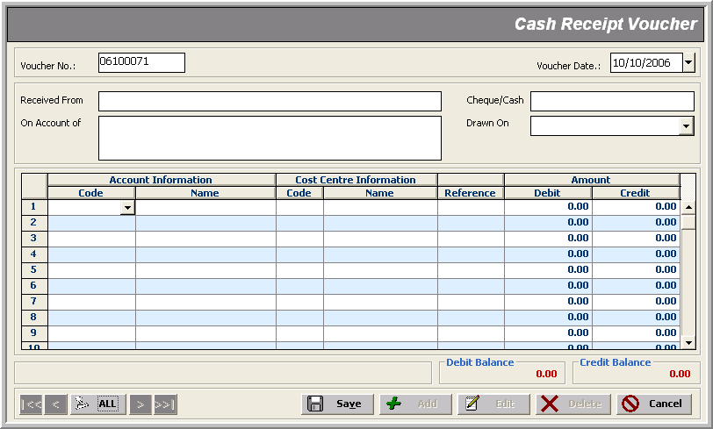
Credit Amount
* Voucher No
* GL Account
Cost Centers
* Voucher Date
* Received From Code
* On Account of
Debit Amount

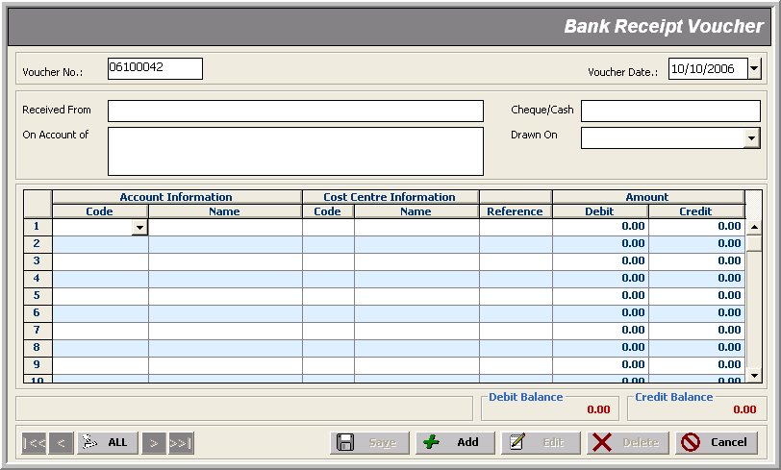
Credit Amount
* Voucher No
* GL Account
Cost Centers
* Voucher Date
* Received From Code
* On Account of
Debit Amount
* Check No

Note that:
- Creating Cash Receipt Voucher or Bank Receipt Voucher on behalf of ‘customers’ for normal users is disallowed:
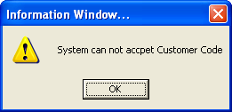
- But an authorized user (e.g. administrator) can select a customer code/title as ‘Account Information’ to be debited/credited; in which case the user is prompted for such an entry through ‘Customer’s Settlement’ entry form:
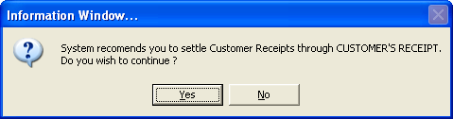
- Similarly, We make Cash Receipt Voucher or Bank Receipt Voucher on behalf of our ‘suppliers' as ‘adjustments’; which is allowed to all users with a confirmation prompt recommending the user to settle such a transaction through Supplier’s Settlement receipt voucher:
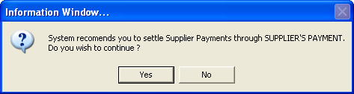
- Unequal ‘debit’ or ‘credit’ totals too raises an indication; though the user CAN proceed to save away such an entry by-passing this difference:
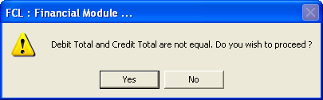

Cash/Bank Payment Voucher _______________________________________________________________________________
Use case: Recording Payments

Description
These forms are used to create Payment Vouchers with the following mandatory data entry:

- Voucher No (Auto generated in ‘yymmnnnn’ format)
- Voucher Date
- Paid To
- Check No (if paying through check; mandatory in case of Bank Payment Voucher)
- Drawn On (the bank with which the check is drawn; mandatory in case of Bank Payment Voucher)
- On Account of
- More than one journal entry against a GL Account

Optional information includes:
- Cost Center

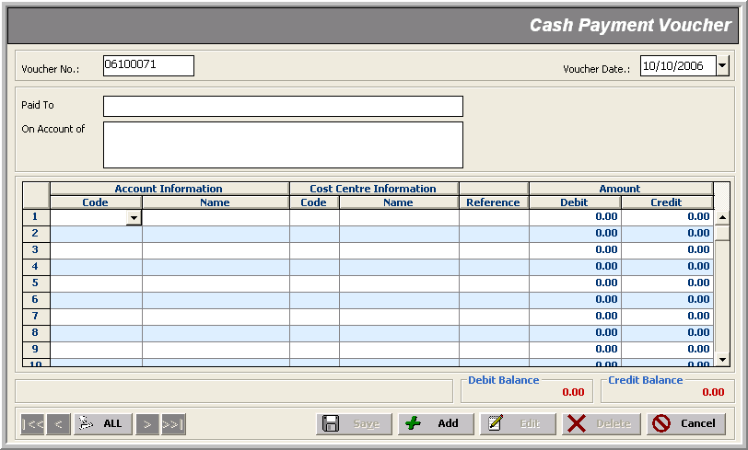
Credit Amount
* Voucher No
* GL Account
Cost Centers
* Voucher Date
* Paid To
* On Account of
Debit Amount

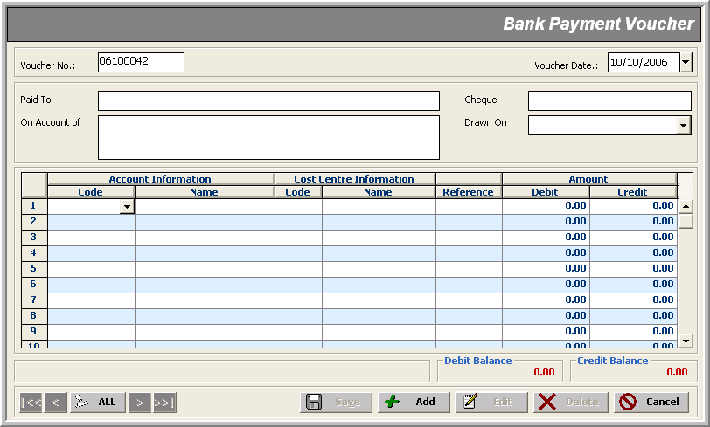
Credit Amount
* Voucher No
* GL Accounts
Cost Centers
* Voucher Date
* Paid To
* On Account of
Debit Amount

Note that:
- Creating Cash Payment Voucher or Bank Payment Voucher on behalf of ‘suppliers’ for normal users is disallowed:
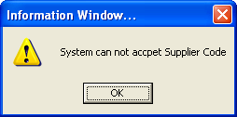
- But an authorized user (e.g. administrator) can select a supplier code/title as ‘Account Information’ to be debited/credited; in which case the user is prompted for such an entry through ‘Supplier Settlement’ entry form:
- Similarly, We make Cash Payment Voucher or Bank Receipt Voucher on behalf of our ‘customers’ as ‘adjustments’; which is allowed to all users with a confirmation prompt recommending the user to settle such a transaction through Customer’s Settlement receipt voucher:
- Unequal ‘debit’ or ‘credit’ totals too raises an indication; though the user CAN proceed to save away such an entry by-passing this difference:
Journal Voucher _______________________________________________________________________________
Use Case: Recording Adjustments to Receipts or Payments

Description
Adjustments to a receipt or a payment transaction is made through a Journal Voucher transaction; FCL’s Financial module allows creating ‘Journal Vouchers’ on behalf of our ‘suppliers' or ‘customers’ as ‘adjustments’ but only an administrator can do that; normal users are disallowed selecting a ‘customer’ or ‘supplier’ account for this transaction.
Here’s the mandatory data entry:

- Voucher No (Auto generated in ‘yymmnnnn’ format)
- Voucher Date
- Narration
- More than one journal entry against a GL Account

Optional information includes:
- Cost Center

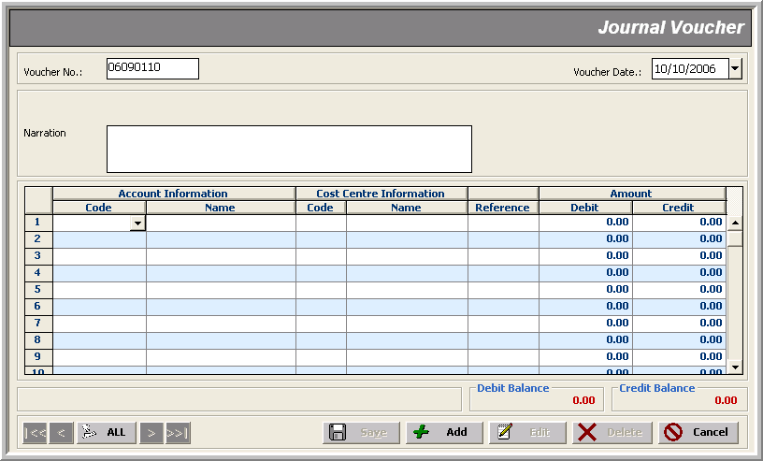
Credit Amount
* Voucher No
* GL Account
Cost Centers
* Voucher Date
* Narration
Debit Amount

Note that:
- The authorized user, when creating ‘Journal Vouchers’ on behalf of a customer or a supplier as ‘adjustments’, is recommended with the relevant customer/supplier settlement transaction

Purchase Voucher ___________________________________________________________________________
USE Case: Paying for a Purchase

Sale

Description
This form is used to record ‘other payments’ against a purchase with the following mandatory data entry:

- Voucher No (Auto generated in ‘yymmnnnn’ format)
- Voucher Date
- Narration
- More than one journal entry against a GL Account

Optional information includes:
- Cost Center

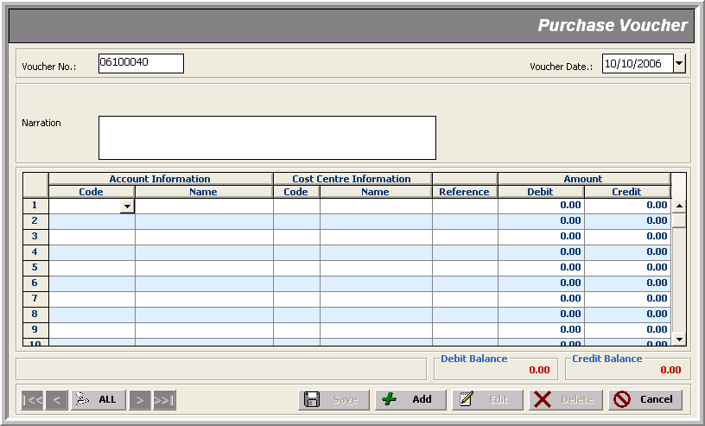
Credit Amount
* Voucher No
* GL Account
Cost Centers
* Voucher Date
* Narration
Debit Amount

Note that:
- All users can make ‘payments’ against a supplier with a Purchase Voucher; creating ‘Purchase Voucher’ on behalf of ‘customers’ is disallowed for normal users; only an administrator can do that in case of an adjustment (again the system recommends to settle the customer through a Customer's Settlement transaction

Sale Voucher ___________________________________________________________________________
USE CASE: Recording Receipt against a Sale

Rate
Rate
Customer

Description
This form is used to record ‘other sales’ against a sale with the following mandatory data entry:

- Voucher No (Auto generated in ‘yymmnnnn’ format)
- Voucher Date
- Narration
- More than one journal entry against a GL Account

Optional information includes:
- Cost Center

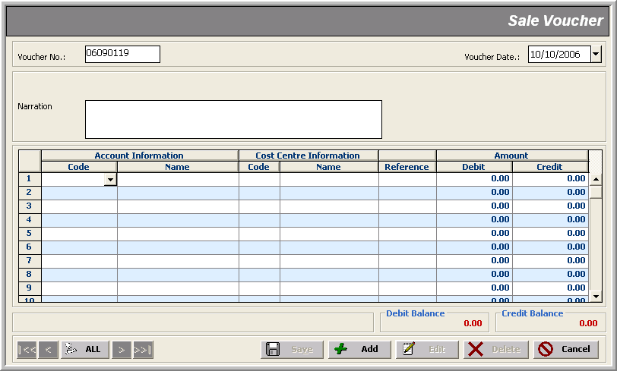
Credit Amount
* Voucher No
* GL Account
Cost Centers
* Voucher Date
* Narration
Debit Amount

Note that:
- All users can record ‘receipts’ against a customer with a Sale Voucher; creating ‘Sale Voucher on behalf of ‘suppliers’ is disallowed for normal users; only an administrator can do that in case of an adjustment (again the system recommends to settle the supplier through a Supplier's Settlement

Supplier’s Settlement _______________________________________________________________________________
USE CASE: Clearing up Bills against a Supplier

Rate
Rate
Customer

Description
This form is used to ‘settle’ a supplier’s bill against a Purchase Voucher created by an FCL Inventory module applying government’s tax rules as specified by the administrator.

Here’s the mandatory data entry:

- Nature
- Voucher No (Auto generated in ‘yymmnnnn’ format)
- Voucher Date
- Supplier
- Credit Account: Bank Code, Check No, Drawn on (in case Nature is Bank Voucher)
- Credit Account: Cash Code (in case Nature is Cash Voucher)
- On Account Of (disabled for editing; relates to Bill-Ref value in the journal entry)
- one or more Purchase Vouchers to be settled in ‘the journal entry grid’

The only optional information is:
- Remarks

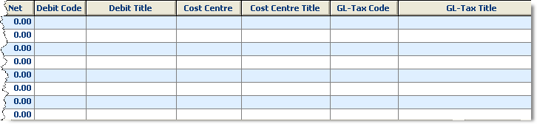
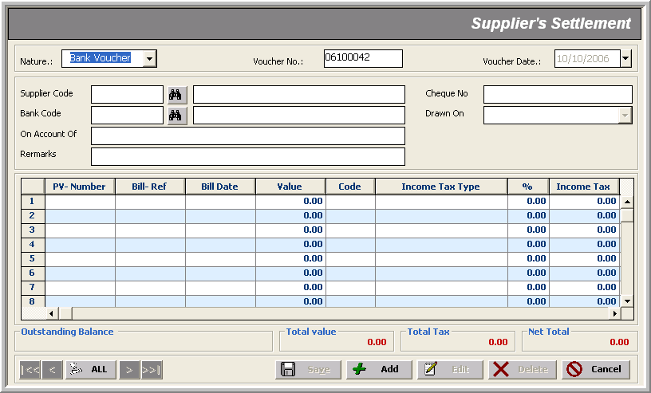
Income Tax Info Amount
* Voucher Nature
* On Account of (Bill-Ref)
* Bill Amount
* Voucher Date
* Supplier
* Bank Account
* Check Info
PV
Tax+Value
* GL Account
Cost Center
GL-Tax Account
Note that:
- The settlement’s header/master information changes with respect to the nature of transaction selected from the top left combo
- All header fields are mandatory except Remarks
- There’s a direct relation between a particular ‘PV-Number’ selection and its corresponding amount ‘value’; for some adjusting entries, negative ‘value’ input is possible; for others, only positive ‘value’ input is possible; otherwise you are denied with an alert:
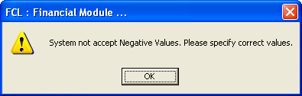
OR
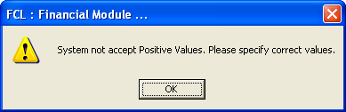
- The constraints such as specifying amount ‘value’ AND ‘GL Account Codes’/ ‘Cost Center’ against a particular ‘PV-Number’ selection is as follows:
PV-Number Value GL-Codes/Cost Center GL-Codes/Cost Center
(for normal users) (for administrator)
Advance -ive, +ive not selectable not selectable
Previous +ive not selectable not selectable
Paid +ive not selectable not selectable
Adjustment -ive, +ive not selectable not selectable
CP -ive, +ive selectable selectable
Round Off -ive, +ive selectable selectable
<BLANK> -ive, +ive selectable selectable
<PV-No> +ive not selectable not selectable
- For a <PV-No> selection, Bill-Ref fetches the original Bill No from that transaction; for <BLANK> selection, it sets ‘Nil’; for all other ‘PV-Number’ types, it is mandatory, otherwise the system demands a Bill-Ref with this bark:
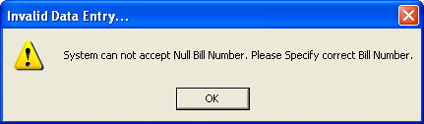
- For a <PV-No> selection, you can’t enter greater (less is OK) amount ‘value’ than actually ‘billed’ amount:
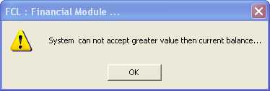
- Only the administrator can change ‘GL Tax Code’ for a settlement

Customer’s Settlement _______________________________________________________________________________
USE CASE: Recording Invoices against Customers

Rate
Rate
Customer

Description
This form is used to ‘settle’ an invoice against a customer created by the FCL Finished Goods Inventory module applying government’s tax rules as specified by the administrator.

Here’s the mandatory data entry:

- Nature
- Voucher No (Auto generated in ‘yymmnnnn’ format)
- Voucher Date
- Customer
- Debit Account: Bank Code, Check No, Drawn on (in case Nature is Bank Voucher)
- Debit Account: Cash Code (in case Nature is Cash Voucher)
- On Account Of (disabled for editing; relates to Invoice reference value in the journal entry)
- one or more invoices to be settled in ‘the journal entry grid’

The only optional information is:
- Remarks

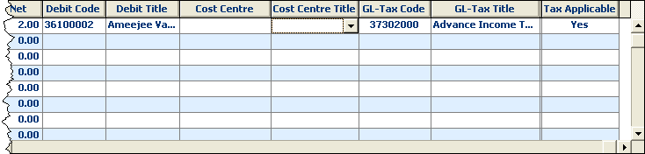
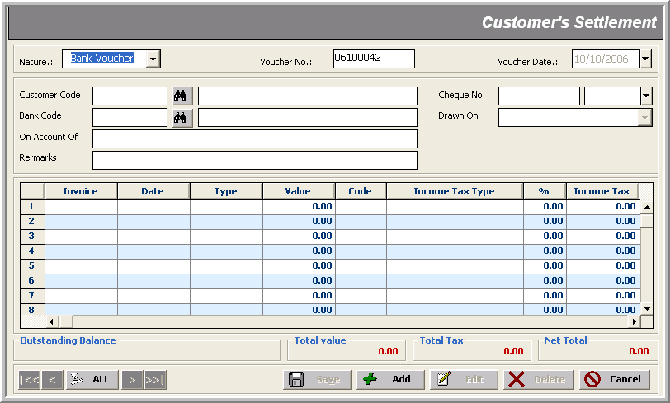
Income Tax Info Amount
* Voucher Nature
* On Account of(Invoice)
* Invoice Amount
* Voucher Date
* Customer
* Bank
* Check Info
Value+Tax
* GL Account
Invoice
Cost Center
GL-Tax Account

Note that:
- The settlement’s header/master information changes with respect to the nature of transaction selected from the top left combo
- All header fields are mandatory except Remarks
- There’s a direct relation between a particular ‘Invoice’ selection and its corresponding amount ‘value’; for some adjusting entries, negative ‘value’ input is possible; for others, only positive ‘value’ input is possible; otherwise you are denied with an alert:
OR
- The constraints such as specifying amount ‘value’ AND ‘GL Account Codes’/ ‘Cost Center’ against a particular ‘Invoice selection is as follows:
Invoice Value GL-Codes/Cost Center GL-Codes/Cost Center
(for normal users) (for administrator)
Debit Note +ive not selectable not selectable
Credit Note -ive not selectable not selectable
Advance +ive,-ive not selectable not selectable
Consolidate +ive not selectable not selectable
Adjustment -ive not selectable not selectable
Round Off -ive, +ive selectable selectable
Others -ive, +ive selectable selectable
<BLANK> (currently not allowed)
<Invoice No> +ive not selectable not selectable
- < BLANK > selection, is currently disallowed:
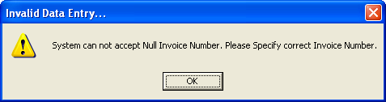
- For a <Invoice No> selection, you can’t enter greater (less is OK) amount ‘value’ than actually ‘billed’ amount:
- Only the administrator can change ‘GL Tax Code’ for a settlement

Reports
_______________________________________________________________________________

The Financial module reports can be divided in three categories:

- Setup Reports
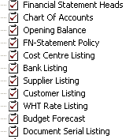
- Transaction Activities Reports
- Financial Statements Reports
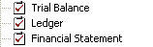
- Utility Reports
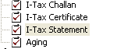

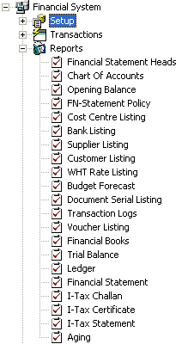 | 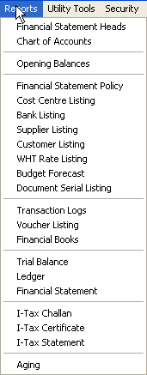

Utility Tools
_______________________________________________________________________________

Utility Tools cover periodic processes within a closing schedule life-cycle, such as:

- Auditing
- Posting/Un-Posting Transactions
- JV Generation
- SV Generation
- Tax Payment
- Tax Challan Process
- Receivables & Payables Process
- Cash Physical
- Supplier’s Exemption

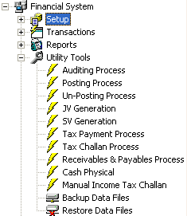 | 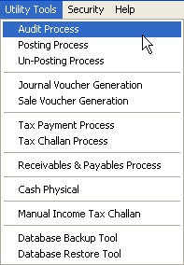

Auditing Process _______________________________________________________________________________

Description
Auditing Process is performed to trace out buggy transaction activities. It performs the following checks on all transactions made:

- Date mismatch
- Whether a process (say, Auditing, Posting, Un-Posting, Journal Voucher Generation, Sale Voucher Generation or R/P Generation) is already running
- Checks for ‘un-balanced’ vouchers (i.e. where Dr and Cr Amount mismatch) and ‘Invalid Account Codes’
- Scans through all the transactions and updates the status as ‘lock’ or ‘unlock’

Here’s how it proceeds:

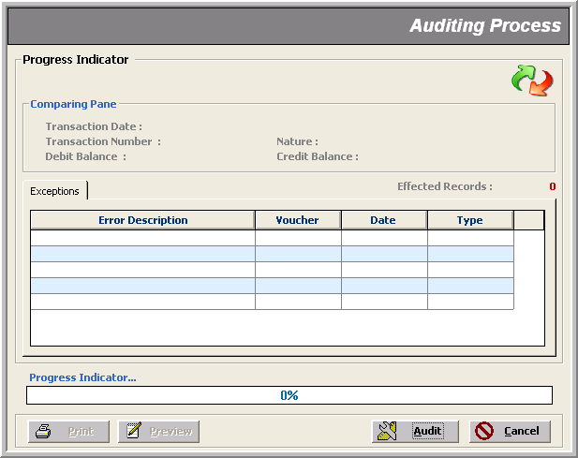
When is clicked, the following window appears indicating the start of Auditing Process.

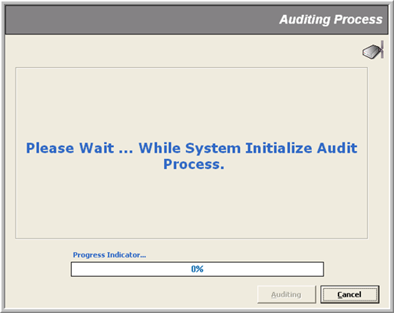

Next window shows that the Auditing Process is checking through transaction activities for possible bugs.
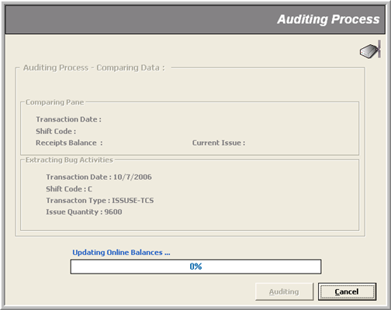
On successful check, a message box pops up saying ‘System did not found any Exception’.

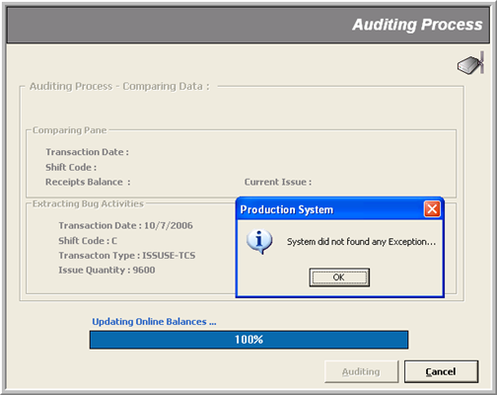s
Posting Process _______________________________________________________________________________

Description
Posting Process is performed to Post transactions in non-editable mode to tag them as ‘confirmed’ transactions. It performs the following tasks:

- Runs the ‘Auditing’ process up to date
- Locks all the selected or checked types of transactions for editing

Here’s how it proceeds:
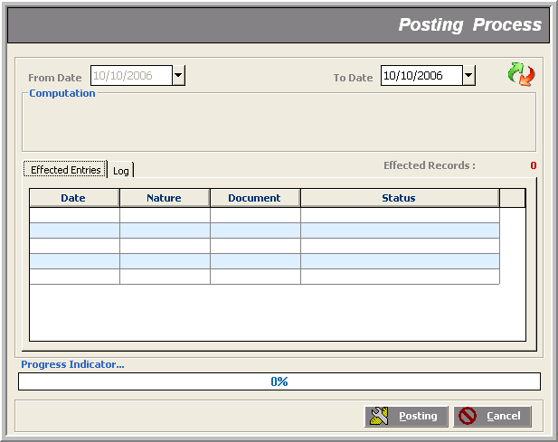

As Posting Process involves Auditing Process, so the system shows up the same screens as in the previous section; later, it initializes the Posting Process; and on finding un-posted data, a message box pops up asking for confirmation to go on. Next window shows the scan progress for un-posted transactions. Finally, a message box flags the end of process.

Un-Posting Process _______________________________________________________________________________

Description
Un-Posting Process performs the following jobs:

- Whether a process (say, Auditing, Posting, Un-Posting, Journal Voucher Generation, Sale Voucher Generation or R/P Generation) is already running
- If some transaction types are checked AND their respective document no.’s range is provided; it ‘unlocks’ those documents for editing; other wise only first task is done

Note that:
- In Un-Posting Process, ’To Date’ is disabled meaning that the process ‘Un-Posts’ only those transactions that were recorded from ‘From Date’ until NOW
- This impacts the relevant reports in that now you can view only those transaction records that were made until the ‘From Date’ specified (all those ‘Posted’ to date)

Here’s how it proceeds:
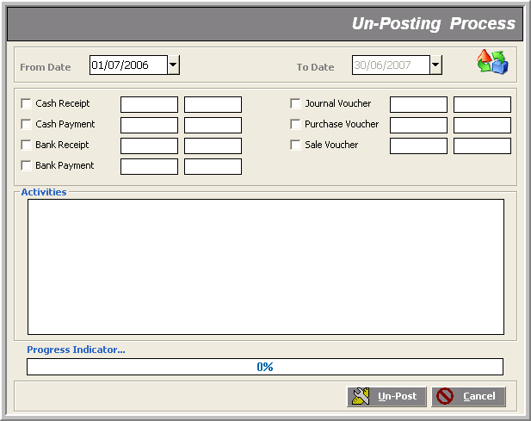

The process signals its successful finish giving a short description of the ‘Activities’ in the text area. If we had given document numbers’ range of a selected transaction nature, the process would have ‘unlocked’ those documents for editing

JV Generation _______________________________________________________________________________

Description
This is a ‘cost recognition’ process which generates a single Journal Voucher for all or any selected inventory modules after scanning through all the transactions made therein on that particular date. This process makes sure whether all kinds of validations are satisfied; such as:
- no other process is running
- specified date for the Journal Voucher to be generated does lie within the fiscal year
- transaction date provided is not posted/locked by the system(s)
- data of the selected inventory stores is posted

Note that:
- This is subject to the company’s policy that :
- all costing is evaluated through Journal Vouchers
- which inventory modules, already ‘pre-defined’ in the database, are to be used for costing
- As soon as the names of target modules are changed in the database, this tool smartly recognizes to include them in the process automatically

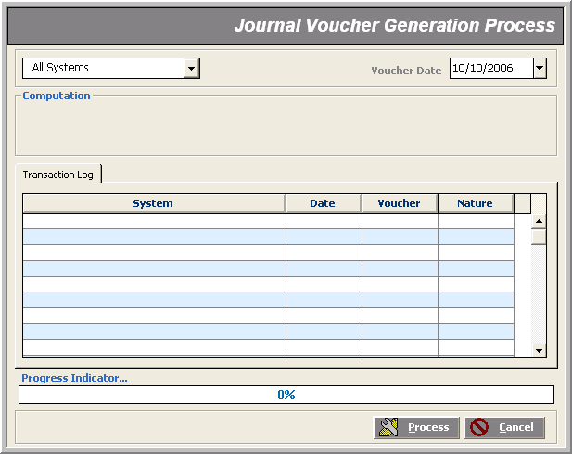
SV Generation _______________________________________________________________________________

Description
This is a ‘revenue recognition’ process which generates Sale Vouchers for all the transactions made in Finished Goods store on that particular date. This process too first makes sure whether all kinds of validations are satisfied; such as:
- no other process is running
- specified date for the Journal Voucher to be generated does lie within the fiscal year
- transaction date provided is not posted/locked by the system(s)
- data of the selected inventory stores is posted

Note that:
- This is subject to the company’s policy that :
- the revenue is to be generated only through Sale Vouchers
- which inventory modules, only the Finished Goods Store as yet, are to be ‘pre-defined’ in the database for the company’s ‘revenue’ estimate
- As soon as the names of target modules are changed in the database, this tool smartly recognizes to include them in the process automatically

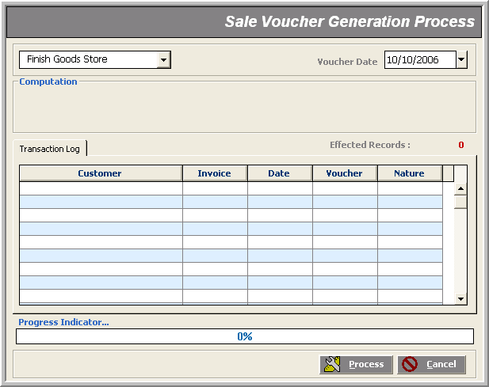
Tax Payment Process _______________________________________________________________________________

Description
This tool tags all the settlement payment transactions performed within the specified date range with the following tax payment information:

1. Check No
2. Check Date
3. Check Bank
4. Bank to be deposited on (SBP/NBP)

Note that:
- This process can be run on both Posted and Un-Posted transactions
- This is the first step of tax payment process; the administrator has to generate Tax Challans with the help of I-Tax Challan report, submit them to the specified bank (SBP/NBP), then run the Tax Challan Process after entering the bank-provided challan no and with the bank’s Challan Date; this completes the tax payment process

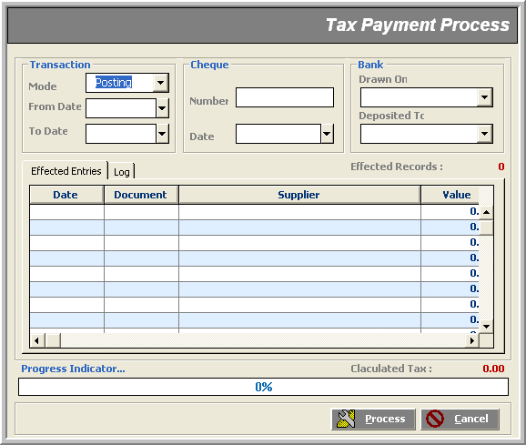
Tax Challan Process _______________________________________________________________________________

Description
Here all transactions whose tax is paid off through Tax Payment Process are assigned a ‘Challan No.’ and the bank’s ‘Challan Date’ in the ‘Challan’ and ‘Date’ columns of the grid.

Note that:
- This completes the tax payment process

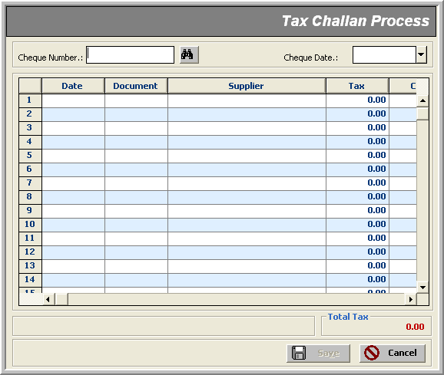

Receivables & Payables Process _______________________________________________________________________________

Description
This tool scans through all settlement transactions and finalizes ‘receivables’ and ‘payables’.

Note that:
- Nothing special is done on behalf of ‘Payables’; this process, though, does fair bit amount of ‘tagging’ behind the scene so that all receivables fully paid up are ‘consolidated’ and no ‘settled’ invoices stalk in customer settlement transactions

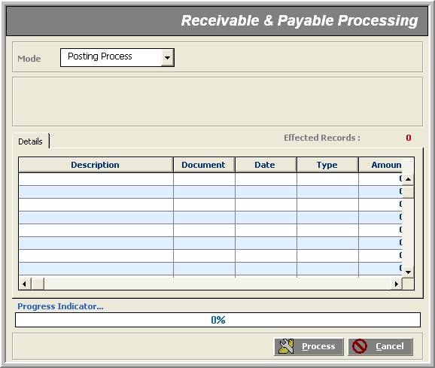

Cash Physical Process _______________________________________________________________________________

Description
An accountant job- This tool keeps a day-to-day record of cash with all kinds of currency-breakups.

Note that:
- This data is stand-alone; it has no link with anything else of the FCL Financial Module

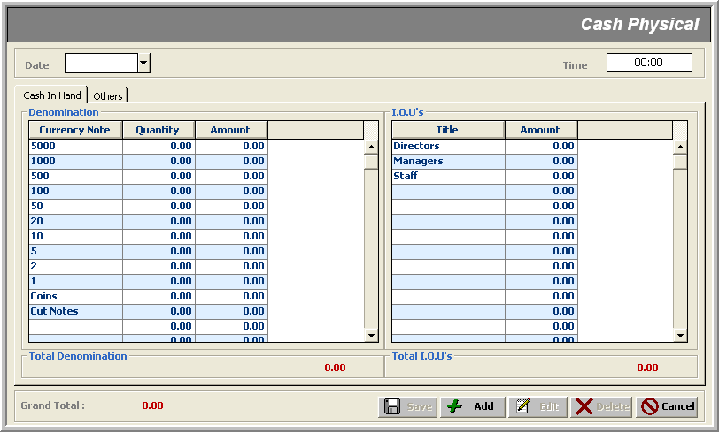

Manual Income Tax Challan Process _______________________________________________________________________________

Description
This is a utility tool that helps create a supplier’s Income Tax Challan ‘manually’ in case I-Tax Challan report data is not acceptable for a particular supplier.

Note that:
- The input data entered here is ‘print-only’; no copy is saved in the database

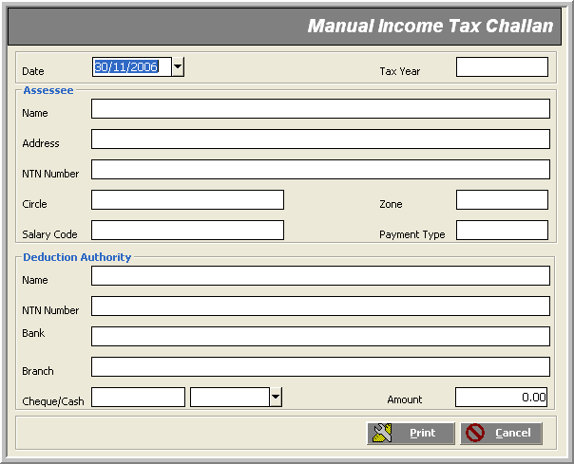

Supplier Exemption Process _______________________________________________________________________________

Description
Here we specify which supplier is ‘exempted’ from Tax deduction. The government’s certificate is provided in the Narration field.

Note that:
- Such an exemption reflects on I-Tax Statement report of ‘exempted’ suppliers so that their exemption certificate no. is mentioned as the ‘Reason for Non-Collection/Non-Deduction’

